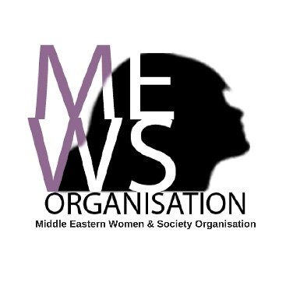
Middle Eastern Women and Society Organisation
Referral Form
Advice and Support Service
Date of referral:
Please enter your name and contact details:
Referrer’s name
Organisation name
Contact number
Contact email
How did you find out about our service? | Flyer/ poster ☐  Online ☐  Word of mouth ☐  Made a referral before ☐  Used the service before ☐  Another service ☐  Other ☐

Please enter the name and DOB of the person you’re referring:
First name
Last name
Other/ previous names
Date of birth

Reason for referral
Please tell us the reason you’re making a referral today, and how you feel the client could benefit from our support.
Client referred for support around (tick all that apply)
Advice involving children ☐  One-to-one English Language Support ☐  Loneliness ☐  Education Advice ☐  Mental and wellbeing Health ☐  Befriending ☐  Counselling ☐  Domestic Violence or Abuse ☐  Training and Awareness Workshops ☐ | Interpreting ☐  Housing Advice ☐  Benefits Advice ☐  Financial Advice ☐  Immigration Advice ☐  Employment Advice ☐  Relationship Advice ☐  Join Social Club ☐  Join Exercise Class ☐  Other ☐

Information about the person being referred
Contact type | Details |  | Safe to contact?
Telephone |  |  | Yes ☐  No ☐
Email |  |  | Yes ☐  No ☐
Address |  |  | Yes ☐  No ☐
Postcode
City
Borough where currently resident
Is the client living with the perpetrator/s? | Yes ☐ No ☐ N/A ☐
Is the client currently in refuge accommodation? | Yes ☐ No ☐
Does the client have children? | Yes ☐ No ☐
How many children does the client have and what are their ages?
Primary language
Other languages spoken
Client’s gender | Female ☐ Male ☐
Is the client’s gender different to the gender they were born with? (Are they transgender?) | Yes ☐ No ☐ Don’t know ☐
What is their nationality? | Don’t know ☐
What is their relationship status?  (tick one option) | Civil partnership ☐  Married ☐  Divorced ☐  Separated ☐  Cohabiting ☐ | Polygamous relationship☐  Widowed ☐  Single ☐  Don’t know ☐
What is their sexual orientation?  (tick one option) | Heterosexual/ straight ☐  Gay woman/ Lesbian ☐  Bisexual ☐ | Other:_________________  Don’t know ☐

Client History
Coercive control ☐  Physical abuse ☐  Sexual abuse ☐  Emotional/psychological abuse ☐  Financial abuse ☐  Harassment/ stalking ☐  FGM ☐  Forced Marriage ☐  Arranged Marriage ☐ |  | Depression ☐  Bipolar☐  Anxiety ☐  PTSD ☐  Other mental health issue ☐  Eating Disorder ☐  Self-harm ☐  Aggressive or violent behaviour ☐  Other ☐
Is the client currently in receipt of any other form of therapy/ seeing any other healthcare professional at present? (e.g. psychologist/psychiatrist) |  | Yes ☐ No ☐
Disability
Any disability? | Physical☐  Learning☐  Deaf/ hard of hearing☐  Blind/ visually impaired ☐  Other ☐
Notes:
Please tell us more about any support needs the client may have:
 | Comments
Support needs around mental health? | Yes ☐  No ☐  Not sure ☐
Interpreter required? | All of the time ☐  Some of the time ☐  No ☐  Not sure ☐
Does the client have any accessibility requirements? | Yes ☐  No ☐  Not sure ☐
If you have any other important/ useful information about this woman’s support needs, please provide additional details below:
Are there any known risks to working with this client?

Please provide information for client’s GP
GP Surgery Name
GP Surgery Address
GP Surgery Telephone Number

Please provide information for client’s next of kin/ someone we can contact in an emergency
Name
Relationship
Contact info
Safe contact notes

Please email the referral form back to:
office@mewso.org

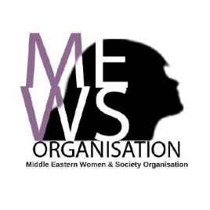
Postal address: Middle Eastern Women and Society organisation, Durham Road Resource Centre, 86 Durham Road, London N7 7DT
Middle Eastern Women and Society Organisation supports Middle Eastern, North African and Asian women in London to rebuild their lives. We reject every form of discrimination, inequality and exclusion and aspire to a society where every woman lives in safety with equal opportunities. We hope for a society in which diversity is considered an element of strength and not of division. The Middle Eastern Women and Society organisation is built on the values of secularism, solidarity and social justice.

